IMPORTANT DRAMA INFO AND TRANSPORTATION PERMISSION FORM
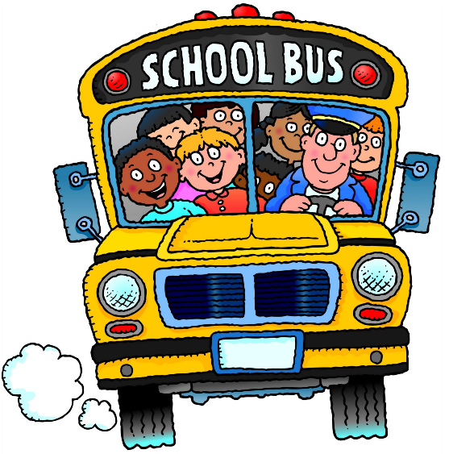
Dear Elementary Drama Husky Family,
Please take note the following items:
- ONE-WAY BUSSING: There has been a change to what was to have been the ‘final’ schedule for the drama festival. A fourth school has been moved to Wednesday’s program. As a result, the day will be starting before noon so we will be taking a school bus to the festival in the morning. We will be leaving the school at approximately 9:15. The bus will NOT be returning students at the end of the day. I am sorry for any inconvenience this change in scheduling may cause you.
- ATTENDING THE PLAYS: You are most welcome to attend any/all of the performances on Wednesday. Please be mindful that there is no food or drink permitted in the auditorium and that a monetary donation basket will be at the door of the auditorium to help support next year’s festival.
- PARKING AT OHS: Parking at OHS is limited. If you park in the school’s fire lane or bus loading area, you can be ticketed and/or towed. It is recommended that you arrive early, park legally nearby, and walk to OHS.
Schedule for Wed, April 11th
Time | Performances
10:30 – 11:30 | Gesner St. School
11:30 -12:00 | LUNCH
12:00 – 1:00 | Gagetown School
1:00 - 2:00 | Hubbard Elem.
2:00 – 3:00 | CNCS
3:00 – 3:30 | SNACK (provided by festival)
3:30 – 4:00 | WORKSHOPS
4:15 - 4:45 | AWARDS CEREMONY

Please sign and return the following permission form.
_ _ __ __ _ _ _ _ __ _ _ _ _ _ _ _ __ _ _ _ __ _ _ _ _ _ _ _ _

My child; _________________ has permission to travel by bus to Oromocto High School to participate in the OEC/FEC Elementary Drama Festival on April 11th.

Signature of Parent/Guardian: __________________________________________

